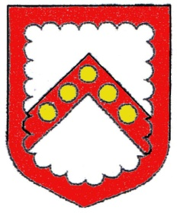
Cheddleton Parish Council

Clerk: Mrs. Melanie Matthews Mobile: 07488 314605
Email: clerk@cheddleton-pc.gov.uk

Dear Councillors,

Meeting regarding Community Centre Car Park

There will be a meeting held regarding the Community Centre Car Park in Community Centre, Hollow Lane, Cheddleton on Tuesday, 13th. January 2026 at 7pm.

The press and public are invited to attend the meeting. No decisions/ resolutions will be made at this meeting, all recommendations to be formally voted on at Full Council. Following this meeting will be the finance committee meeting where press/ public will not be invited.

Yours sincerely,
Mrs. M Matthews
Parish Clerk and RFO

AGENDA

- History of Car Park Issues
Members of public, councillors and caretaker have opportunity to explain history – maximum 3 minutes per person and total 15 minutes overall.
- Opening Times
Suggestions on opening times/ ANPR, input from councillors and caretaker
- Permits
Suggestions on permits requirements: number of spaces, affordable costings, allocation. Input from councillors.
- Public Time
Public to give view on discussions and any final comments – maximum 3 minutes per person and total 15 minutes overall.
- Recommendations
To agree recommendations for full council to consider. Councillors only.
End of Meeting

